Awaji Yumebutai Conference Center
1 Yumebutai, Awaji Island, Hyogo 656-2301 Japan
TEL: +81-799-74-1020
FAX: +81-799-74-1021
http://www.yumebutai.org/conf_e/index.html

For the participants who will arrive in Kansai International Airport on January 18, 2004, the meeting service is available at the meeting place indicated below. The service is only available on that day. There will be our staff stands with the signboard “ALOS Workshop in AWAJI.”

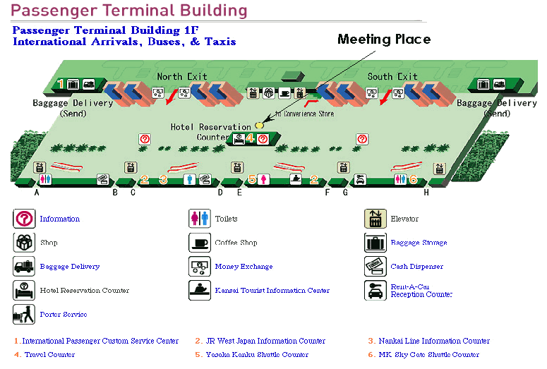
From Kansai International Airport (KIX) to AWAJI Yumebutai Conference Center
PLAN A：Take 2 Buses. 125 (65+60) min. 2700yen (900yen+1800yen)
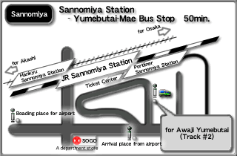
- Please take limousine bus to SANOMIYA-Station. Bus stop #6 can be found at the 1st Fl of KIX passenger terminal. Limousine bus services are available every 20 minutes from 6:30 to 23:30. 65min./1,800yen.
- Transfer to the bus for Awaji Yumebutai at JR Sannomiya Station. Bus services are available once in every hour between 7:20am to 9:50pm. Get off at the "Awaji Yumebutai Mae."
For further details please visit the conference center’s official website.
http://www.yumebutai.org/conf_e/index.html

PLAN B: Take bus and taxi.100 (90+10) min. 4100yen(2500yen+1,600yen)
Please take a limousine bus bound for AWAJI at Bus Stop #2 from the 1st Fl of
KIX passenger terminal. Limousine bus services are available every hour from 8:35 to 20:20. 90min/2500yen.
*When you get off at the Higashiura IC Bus Stop, please call a taxi. For those who do not speak Japanese, The Westin Awaji Island hotel staff could arrange it. A pay phone is in "Yamadahara Kaikan" with orange tiled roof at the right-hand side of the pedestrian footbridge. Please prepare coins for a pay phone.

Ura taxi : 0120-23-8184, 0799-74-3108
Oiso taxi : 0799-74-3121
The Westin Awaji Island : 0799-74-1111
Please take limousine bus to SANOMIYA-Station. Bus stop #6 can be found at the 1st Fl of International arrival gate. Limousine bus services are available every 20 minutes from 6:30 to 23:30. 65min./1,800yen.

From Osaka International Airport (ITM) to AWAJI Yumebutai Conference Center
Take 2 Buses. 100 (40+60) min. 1,920yen (1,020 yen+900yen)
- Please take airport bus to KOBE-SANOMIYA Station. Bus services are available every 20 minutes from 7:45 to 21:00. 40min./1,020yen Bus stops are located both South and North Terminals.
South Terminal- Bus Stop #15
North Terminal- Bus Stop #5
- Transfer to the bus for Awaji Yumebutai at JR Sannomiya Station. Bus services
are available once in every hour between 7:20 am to 7:20 am to 9:50 pm. Get off at “Awaji Yumebutai Mae.”

For further details please visit the conference center’s official website
http://www.yumebutai.org/conf_e/index.html

From Tokyo International Airport (NRT) to AWAJI Yumebutai Conference Center
The trip from Tokyo Intl. Airport to Awaji Yumebutai Conference Center can be very long and tiresome. The traveling time is estimated at least 5 hours.

Step1: Tokyo Intl-Airport (Take Limousine Bus or Narita Express Train) 60-80 min.
Step2: Tokyo Station (Take Superexpress/Shinkansen Trains) 173-195min

Step3: Shin-Kobe Sta. (Take shuttle bus to Westin Hotel Awaji) 65min
AWAJI Yumebutai Conference Center (Westin Hotel is just nearby)

STEP 1: From Tokyo International Airport to Tokyo Station
- By bus: Airport Limousine Bus 80min/3000yen
You do not have to make bookings for taking the bus leaves from Narita Airport.
http://www.limousinebus.co.jp/e/index_route.html
2) Narita Express Train 60min/3140yen
http://www.jreast.co.jp/nex/e_TimeTable/e_sobu_narita_u/e_sobu_narita1_u/index.html

STEP 2: From Tokyo Station to Shin Kobe Station
You can take Super Express trains (Shinkansen) to Shin-Kobe Station.
TOKAIDO-SHINKANSEN
http://www.jreast.co.jp/e_charge/index.asp
Nozomi Trains (173 min 14,870 yen) or Hikari (195 min 14,470 yen) are the choices, but Kodama trains can be unbearable. Do not take Kodama trains which make local stops.

STEP 3: From Shin-Kobe Station (65min/900yen)
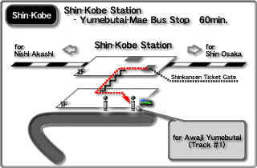
The bus services for YUMEBUTAI-MAE via SANNOMIYA STATION are available every hour between 7:20am and 9:40pm.

