Author Guidelines for ALOS 2010 ABSTRACTs

Author(s) Name(s) ¹, Author(s) Name(s) ²

¹ Author Affiliation(s)
² Author Affiliation(s)

1. Introduction

These guidelines include complete descriptions of the fonts, spacing, and related information for producing your abstracts. Please follow them and if you have any questions, please feel free to contact the conference management service.

2. Formatting your paper

LENGTH: You are allowed a maximum of 1 page for your abstract.
LANGUAGE: All proposals must be in English.
MARGINS: Documents should be formatted for standard letter-size (8-1/2 in. by 11 in.) or A4 (210mm by 297mm) paper
- The left and right margins must be 19 mm.
- The top and bottom margins must be 20 mm.
- The title, author(s), and affiliation(s) should be centered on the page.
- A two-column layout with a single vertical spacing must be used.

TYPE: To achieve the best viewing experience for the review process and conference proceedings, we strongly encourage authors to use Times-Roman font with a font size of 11 points. If a font face is used that is not recognized by the submission system, your proposal will not be reproduced correctly.

3. Page title section

The paper title should be centered, completely capitalized, and in Times 14-point, boldface type. The authors’ name(s) and affiliation(s) appear below the title in capital and lower case letters. Papers with multiple authors and affiliations may require two or more lines for this information.

4. headings

Headings, for example, “1. Introduction”, should appear in all capital letters, bold face, centered in the column, with one blank line before, and one blank line after.

5. Illustrations, graphs, and photographs

Illustrations, if any, must appear within the designated margins. Caption and number every illustration in Times 10-point, boldface type. All halftone illustrations must be clear black and white prints. Color may be used, but it should print clearly on black-only printers.

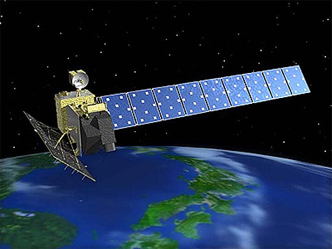
Fig. 1 Artiste view of ALOS

6. References

List and number all bibliographical references at the end of the paper. The references should be numbered in order of appearance in the document. When referring to them in the text, type the corresponding reference number in square brackets as shown at the end of this sentence [1].

[1] A.B. Smith, C.D. Jones, and E.F. Roberts, “Article Title,” Journal, Publisher, Location, pp. 1-10, Date.

